INTERNSHIP REPORT
ON
ARTIFICIAL INTELLIGENCE AND MACHINE LEARNING
Submitted To
School of Computer Science and Engineering
IILM University, Greater Noida, U.P.
In partial fulfilment of the requirement of degree of
B.Tech CSE
By
Name of Student: ARYAN SHARMA
Roll Number: 2410031485
Batch: 2026-27
Internship Duration: 30 Days (Virtual)

CANDIDATE’S DECLARATION
I, ARYAN, do hereby declare that the internship report titled “Artificial Intelligence and Machine Learning” has been completed by me to fulfil the requirement for the award of the degree of Bachelor of Technology in CSE. The report is prepared on the basis of my internship experience and the certificate issued for the internship. I affirm that this report is my own work and has not been submitted to any other institute for any degree/diploma requirement.

Signature: ____________________ Aryan
Student Name: ARYAN SHARMA
Roll No.: 2410031485

ACKNOWLEDGEMENT
I take this opportunity to express my sincere gratitude to everyone who supported me throughout the internship program. I am thankful for the guidance, constructive feedback and valuable learning opportunities provided during the internship. The 30-day virtual internship in Artificial Intelligence and Machine Learning provided me with an opportunity to understand the field and strengthen my academic knowledge. I am also grateful to my parents for their constant support and blessings.

Signature: ____________________ Aryan
Student Name: ARYAN SHARMA
Roll No.: 2410031485

INTERNSHIP COMPLETION CERTIFICATE
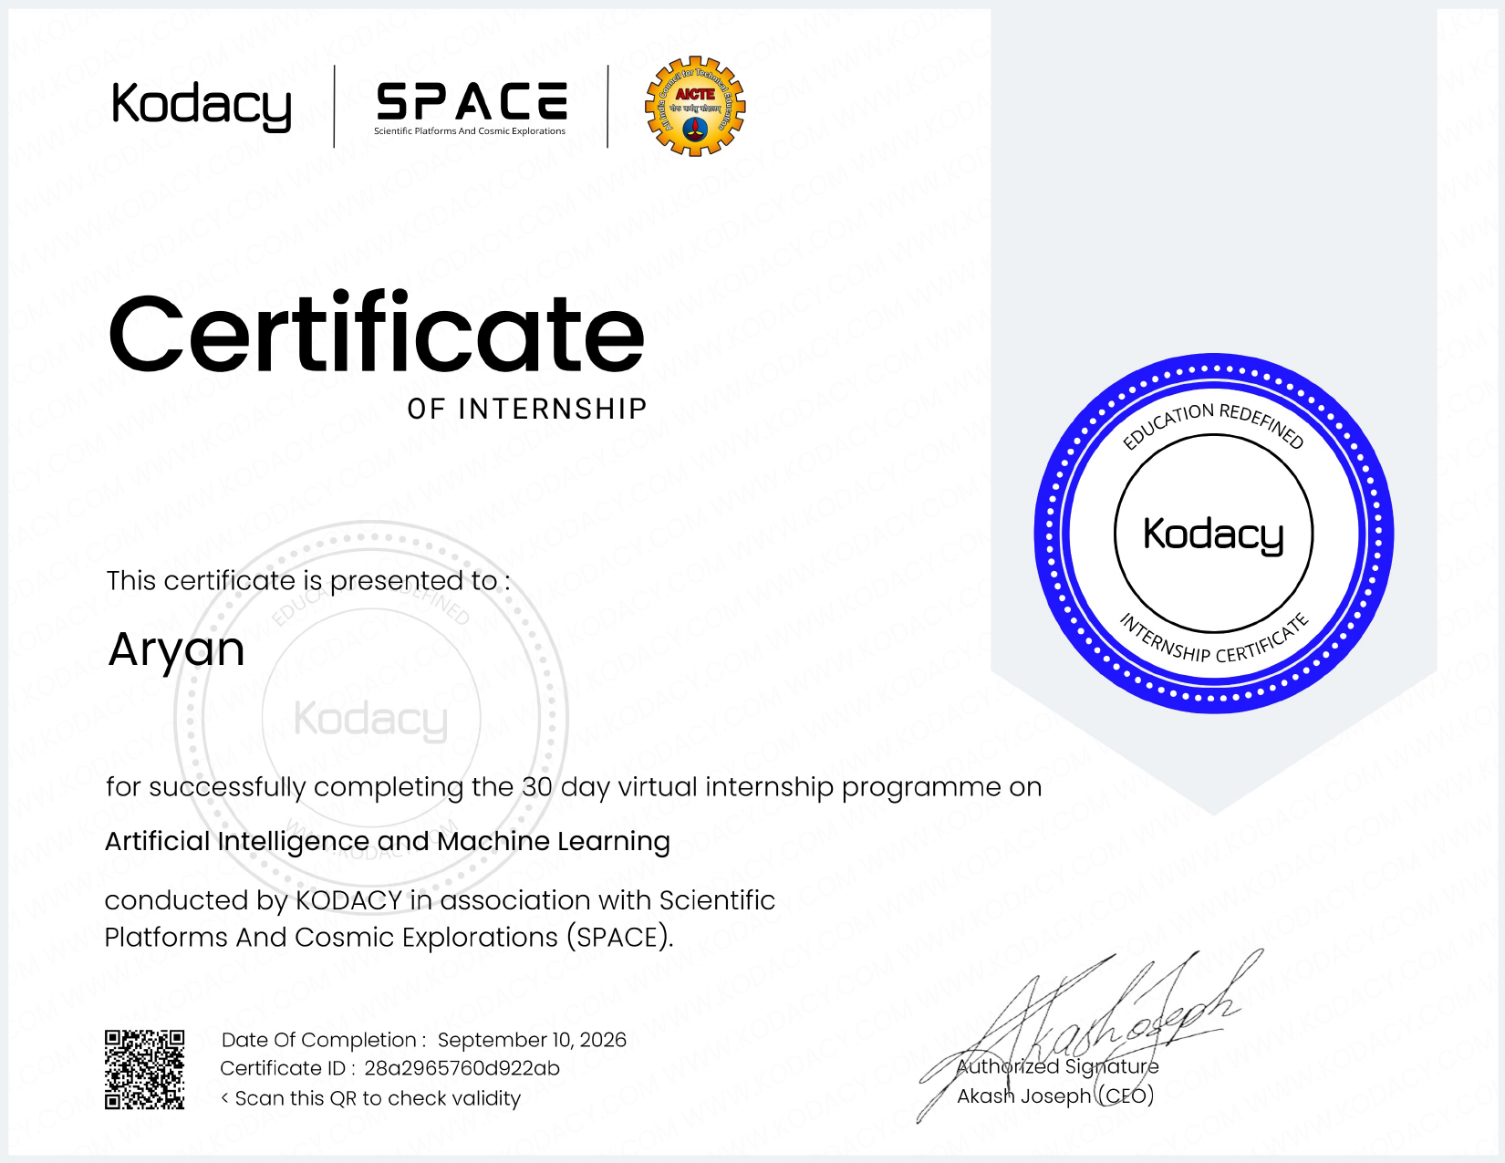

4. PROJECT DESCRIPTION

4.1 Introduction
The internship was a 30-day virtual internship program in Artificial Intelligence and Machine Learning. The certificate confirms successful completion of the program and identifies the internship area as Artificial Intelligence and Machine Learning.

4.2 Organization Profile
The internship certificate was issued by KODACY. The certificate states that the program was conducted by KODACY in association with Scientific Platforms And Cosmic Explorations (SPACE).

4.3 Problem Statement
The internship focused on gaining structured exposure to Artificial Intelligence and Machine Learning during a 30-day virtual program. The main purpose was to develop understanding of the field and connect academic learning with practical internship exposure.

4.4 Project Objectives
- To gain practical exposure to Artificial Intelligence and Machine Learning.
- To understand the basic concepts and applications related to AI and ML.
- To improve technical learning through a structured virtual internship.
- To develop confidence in applying academic concepts to technology-oriented tasks.

4.5 Scope of the Internship
The scope of the internship covers learning and exposure in Artificial Intelligence and Machine Learning through the 30-day virtual internship program. The report is limited to the information supported by the internship certificate and the report format.

4.6 Technologies and Tools Used
The supplied internship certificate confirms the internship domain as Artificial Intelligence and Machine Learning. It does not specify particular programming languages, software tools, libraries, datasets, or platforms; therefore, no specific tools are claimed in this report.

4.7 System Architecture
No specific system architecture is provided in the supplied certificate. Therefore, a technical architecture is not claimed as part of the internship evidence.

4.8 Methodology
The internship was completed as a 30-day virtual program. The methodology consisted of structured learning and internship exposure in the Artificial Intelligence and Machine Learning domain. Detailed task-wise activities are not stated on the supplied certificate.

4.9 Expected Outcomes
- Improved understanding of Artificial Intelligence and Machine Learning.
- Greater awareness of practical applications of AI and ML.
- Development of technical learning and problem-solving skills.
- Completion of a certified 30-day virtual internship program.

4.10 Certificate of Completion
The internship completion certificate is attached as a supporting document in this report. It records the completion of the 30-day virtual internship program in Artificial Intelligence and Machine Learning, with a date of completion of September 10, 2026.

5. BIBLIOGRAPHY / REFERENCES
1. Internship Completion Certificate issued by KODACY in association with Scientific Platforms And Cosmic Explorations (SPACE), dated September 10, 2026.
2. Internship Report Format provided by the School of Computer Science and Engineering, IILM University, Greater Noida, U.P.

